Example 11:

100 kPa
300 K
500 kPa
600 K
300 kPa
450 K
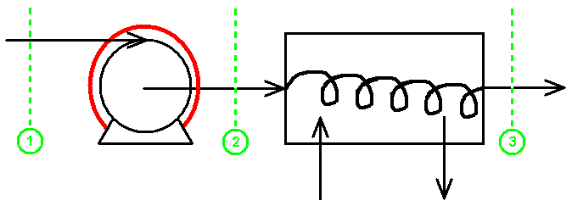
compressor
coolant
(rusty & needs oil)

1) What is the entropy change in each step & overall?

Does reversibility matter?

$${ΔS}_{\text{12}}=C_{P}\text{ln}\frac{T_{2}}{T_{1}}−R\text{ln}\frac{P_{2}}{P_{1}}=6\text{.}\text{79} \frac{J}{g \text{mol} K}$$
Const. P
Const. T

$${ΔS}_{\text{23}}=\text{29}\text{.}1\text{ln}\frac{\text{300}}{\text{600}}−8\text{.}\text{314}\text{ln}\frac{4\text{.}5}{5\text{.}0}=−\text{19}\text{.}3 \frac{J}{g \text{mol} K}$$
$${ΔS}_{\text{13}}=6\text{.}\text{79}−\text{19}\text{.}3=−\text{12}\text{.}5 \frac{J}{g \text{mol} K}$$

- What is the work required for the compression?
$$\begin{aligned}W_{\text{actual}(\text{12})}\text{=+}ΔH\text{=+}C_{P}\left(T_{2}−T_{1}\right)\text{=+}\text{29}\text{.}1\left(\text{300}\right)= \\ +\text{8730} \frac{J}{g \text{mol} K}\end{aligned}$$
Irreversible adiabatic

- What would be the work required for a new, perfect compressor to compress the air to 500 kPa?

A)
$$W_{\text{rev}(1\text{.}2)}\text{=+}ΔH\text{=+}C_{P}\left(T_{4}−T_{1}\right)$$
reversibleadiabatic
?

$$T_{4}=T_{1}{\left(\frac{P_{4}}{P_{1}}\right)}^{\frac{γ−1}{γ}}=\text{300}{\left(\frac{5}{1}\right)}^{\frac{0\text{.}4}{1\text{.}4}}=\text{475} K$$
From A)
$$W_{\text{rev}(\text{12})}=(+\text{29}\text{.}1)(\text{475}−\text{300})\text{=+}\text{5092} \frac{J}{\text{mol}}$$

