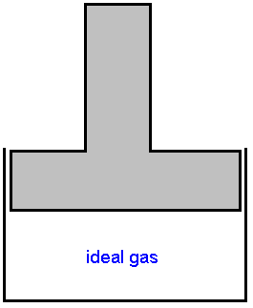
Compress isothermally (irreversibly) at 130° C from 2.5 bar to 6.5 bar. The irreversible work is 30% greater than the reversible work. The heat rejected flows into a heat sink @ 25° C. What is the Δs for the gas, sink, and total?

From previous derivation for an isothermal system:

$$Δ{\underline{s}}_{\text{isothermal}}=−\text{nR}\text{ln}\left(\frac{P_{2}}{P_{1}}\right)=\underline{\underline{−7\text{.}\text{944} \frac{J}{K}}}$$

also here:
$$Q=−W=−\text{RT}\text{ln}\frac{P_{1}}{P_{2}}$$

$${Δs}_{\text{sink}}=\int{−\frac{{\text{dQ}}_{\text{rev}}}{T_{\text{sink}}}}=\text{13}\text{.}\text{96} \frac{J}{K}$$

$${Δs}_{\text{total}}={Δs}_{\text{gas}}+{Δs}_{\text{sink}}=6\text{.}\text{02} \frac{J}{K}$$

Process possible!

For any single phase system in stable equilibrium, any property may be expressed as a function of 2 other independent properties & the mass (moles).

Example:

$$d\underline{U}={\left(\frac{δ \underline{U}}{δ \underline{S}}\right)}_{vδn}d\underline{S}+{\left(\frac{δ \underline{U}}{δ \underline{V}}\right)}_{δV}d\underline{V}$$

The combined 1st & 2nd Law
Open systems

$$d\underline{U}=\text{Td}\underline{S}=\text{Pd}\underline{V}$$

Therefore:
$$T={\left(\frac{δ \underline{U}}{δ \underline{S}}\right)}_{\underline{V},N}$$
$$−P={\left(\frac{δ \underline{U}}{δ \underline{V}}\right)}_{\underline{S},N}$$
$$μ_{i}=\left(\frac{δ \underline{U}}{δ N_{i}}\right)\underline{S},\underline{V},N_{i}$$

