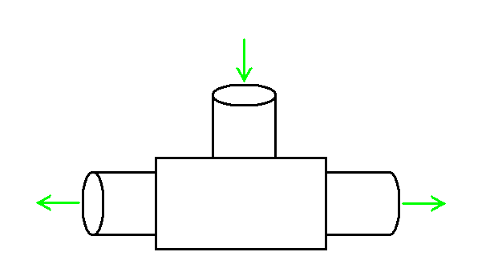Example 10:
P₁ T₁
high pressure

Hilsch Tube
(a tricky device)
P₂ T₂
P₃ T₃
low pressure
hot air
low pressure
cold air

$P_{1}=1\text{.}5 \text{bar}$ $T_{1}=\text{27}° C$
$P_{2}=1\text{.}0 \text{bar}$ $T_{2}=−\text{123}° C$
$P_{3}=1\text{.}0 \text{bar}$ $T_{3}= ?$

Is this devise possible?

Test 1) Is energy conserved?

Test 2) Is ΔS_{Total} ≥ 0?

1st Low for Open systems:

$$d\underline{U}=\text{dQ}+\text{dW}+\sum{\text{hdn}}$$

$$h_{1}n_{1}=h_{2}n_{2}+h_{3}n_{3}$$

$$n_{1}C_{P}T_{1}=n_{2}C_{P}T_{2}+n_{3}C_{P}T_{3}$$

$$2\left(\text{300}\right)=1\left(\text{150}\right)+1\left(T_{3}\right)$$

$$T_{3}=\text{450} K$$
OK so far!

2)

$${ΔS}_{\text{Total}}={ΔS}_{\text{Cold}}+{ΔS}_{\text{Hot}}$$

$$=\left[n_{2}C_{P}\text{ln}\frac{T_{2}}{T_{1}}−n_{2}R\text{ln}\frac{P_{2}}{P_{1}}\right]+\left[n_{3}C_{P}\text{ln}\frac{T_{3}}{T_{1}}−n_{3}R\text{ln}\frac{P_{3}}{P_{1}}\right]$$

$$=\left[\text{29}\text{.}1\text{ln}\frac{\text{150}}{\text{300}}−8\text{.}\text{314}\text{ln}\frac{1}{1\text{.}5}\right]+\left[\text{29}\text{.}1\text{ln}\frac{\text{450}}{\text{300}}−8\text{.}\text{314}\text{ln}\frac{1}{1\text{.}5}\right]$$

$$=−1\text{.}\text{63} \frac{J}{g \text{mol} K}$$
Not possible.

