Example 4:
N₂ reservoir
100 bar

300K

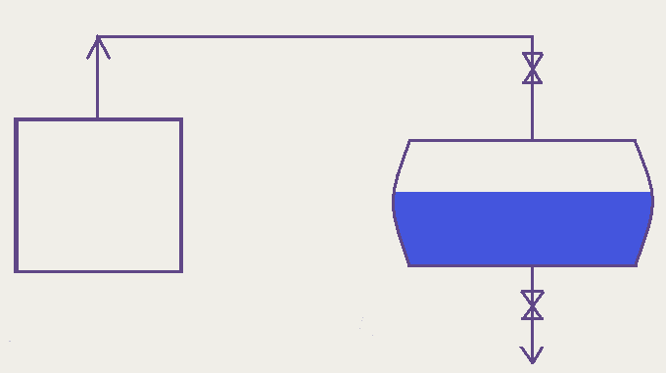
2m³

Large

C_{v} = 20.9 J/mol K
T_{initial} = 280 K

V_{Total} = 4m³

P_{initial} = 1 bar

Step a) Pressurize to 5 bar.

1st Low:
$$d\underline{U}=\text{dQ}+\text{dW}+\sum_{e}{h_{e}{\text{dn}}_{e}}$$
$$−\sum_{l}{h_{l}{\text{dn}}_{l}}$$
Process is fast ∴ Q = 0
In step a) W = 0 (V constant)
Also, nothing is leaving & dn_{l} = 0.

The total energy may be written in terms of specific energy:

$$d\underline{U}=\text{UdN}+\text{NdU}$$
Total internal energy

and h_{e} = constant (large reservoir)

Let n_{e} = N and integrate 1st Law equation:

$$\int{\frac{\text{dU}}{h_{e}−U}=\int{\frac{\text{dN}}{N}}}$$
Constant V.

A ⇒ $\frac{h_{e}−U_{\text{initial}}}{h_{e}−U}=\frac{N}{N_{i}}=\frac{{\text{PT}}_{\text{initial}}}{P_{\text{initial}}T}$

Defining: $h_{e}=C_{p}\left(T_{e}−T_{o}\right)+h_{o}$
Stand. State
$U=C_{v}\left(T−T_{o}\right)+U_{o}$
and $h_{o}=U_{o}+{\text{RT}}_{o}$
same as PV

A becomes:
$$\frac{C_{p}T_{e}−C_{v}T_{\text{initial}}}{C_{p}T_{e}−C_{v}T}=\frac{{\text{PT}}_{\text{initial}}}{P_{\text{initial}}T}$$
or in terms of T:
$$T=\frac{γ T_{e}}{1+\left(P_{\text{initial}}/P\right) \left[γ \left(T_{e}/T_{\text{initial}}\right)−1\right]}$$
abiabatic expansion
Constant V.

here for T_{e} = 300K, T_{i} = 280K
P_{initial} = 1 bar, P = 5 bar, γ = 1.4

$$T=\frac{\left(1\text{.}4\right) \left(\text{300}\right)}{1+\left(1/5\right) \left[1\text{.}4\left(\text{300}/\text{280}\right)−1\right]}=\text{382} K$$

At this time:
$$N=\frac{\text{PV}}{\text{RT}}=\text{315} \text{moles}$$

Also note: that as P>>P_{initial}

$$T→γ\text{Te}$$

independent of the conditions in the tank to begin with!

Step b) The liquid purge is a constant P process (P = 5 bar)

Here:
$$d\underline{U}=\text{UdN}+\text{NdU}$$
total
specific
specific

$$\text{dQ}=0$$

$$−\text{dW}\text{=+}\text{Pd}\underline{V}=\text{PNdV}+\text{PVdN}$$
total
specific
specific

$$∴\text{UdN}+\text{NdU}=−\text{PNdV}−\text{PVdN}+h_{e}\text{dN}$$

or regroup:
$$N\left(\text{dU}+\text{PdV}\right)=\text{Nd}\left(U+\text{PV}\right)=\text{NdH}$$

$$\text{NdH}=\left(h_{e}−\overset{−H}{\overbrace{U−\text{PV}}}\right)\text{dN}$$
integrate:

$$\int{\frac{\text{dH}}{h_{e}−H}}=\int{\frac{\text{dN}}{N}}$$
yields:
$$\frac{h_{e}−H_{\text{initial}}}{h_{e}−H}=\frac{N}{N_{\text{initial}}}=\frac{\underline{V}T_{\text{initial}}}{{\underline{V}}_{\text{initial}}T}=\frac{T_{e}−T_{i}}{T_{e}−T}$$

Solving for T:
$$T=\frac{T_{e}}{\left(V_{\text{initial}}/V\right) \left[\left(T_{e}/T_{\text{initial}}\right)−1\right]+1}$$
Constant P!

When the tank is drained:

V = 4 m³, T_{e} = 300 K, T_{initial} = 382 K
V = 2V_{I}
Part (a)

$$T=\frac{\text{300}}{\left(1/2\right) \left[\left(\text{300}/\text{382}\right)−1\right]+1}=\underline{\underline{\text{336} K}}$$

